Véronique Gens: Passion
Arias and scenes by Lully, Charpentier and Desmarets. Ensemble Les Surprises, Bestion de Camboulas. Texts and translations. Alpha 747
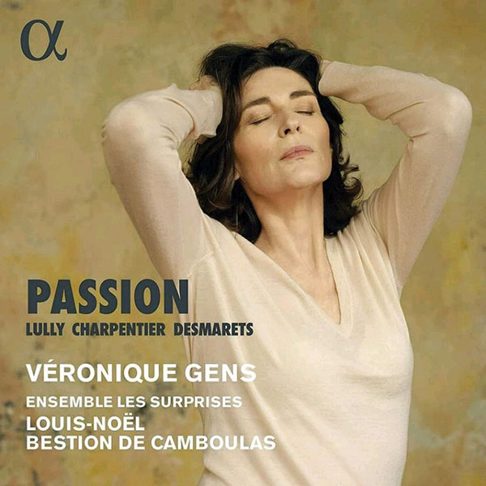
FRENCH SOPRANO Véronique Gens returns to the world of early music, where she got her start in William Christie’s Arts Florissants, with a recital of operatic excerpts from the French Baroque. The ensemble Les Surprises, under Louis-Noël Bestion de Camboulas, contributes luscious support with sensuous and detailed playing.
An imaginary opera in five acts provides the framework for a grab-bag of arias, scenes, choruses and instrumental excerpts, from the well-known to the newly recorded. Disappointingly skimpy program notes leave the listener unaware of the dramatic context or content of the various excerpts, and a somewhat generic presentation doesn’t help. It’s as if the artists created the clever lineup, then just read through the pieces.
It helps that the music is superb (Lully knew what he was doing theatrically), and that the artists understand the style, delivery, tempos and structures, as well as the standard tropes—soothing sleep scene, summoning of infernal spirits, tempest with thunder, etc.—and are able to infuse each excerpt with clarity and, in the case of Gens, nobility. If, as the program booklet states, French singing actresses were expected to display “authority and vehemence,” Gens prioritizes the first. In the roles created by the superstar Mlle. Le Rochois—Lully’s Armide and Charpentier’s Médée—Gens’s essentially sweet and rounded sound fails to capture the dramatic depth, quick changes of mood and vocal variety of the moment.
Most successful is the “Air de la Nuit,” from Lully’s Triomphe de L’Amour, in which the airy, spacious playing—low strings contrasting with high, soft winds—surrounds Gens’s comforting, tranquil performance. A fun segue leads into a lovely sleep chorus, with low voices and descending lines, from Henri Desmarets’s Diane de Fontainebleau.
Act I of the fanciful opera features infernal invocations from Lully’s Amadis and Pascal Collasse’s Achille et Polyxène, the latter a little-known work in which, in this excerpt, Juno reassures someone that a dreaded marriage will not take place. Gens makes effective use of her chest voice here, while the following tempest, from Collasse’s Thétis et Pélée, showcases the precision and verve of the strings.
Gens brings understated elegance to Cybèle’s outpouring of unrequited love from Lully’s Atys and captures the quick changes and contrasting psychological states of the troubled sorceress Armide as she prepares to kill the sleeping Renaud, but she substitutes overwhelming vibrato for emotional force. —Judith Malafronte

